
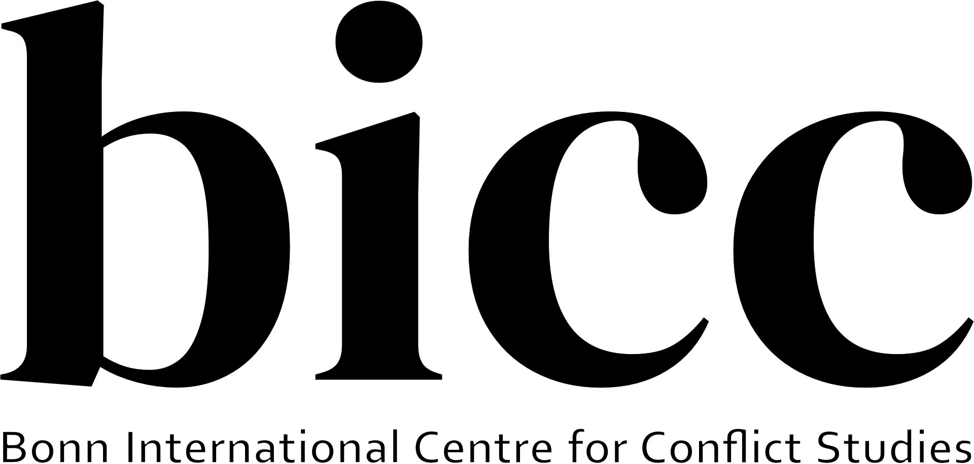

Call for Abstracts/Papers
Second Colloquium on Peace, Conflict and Reconciliation Studies
The Bonner Center for Reconciliation Studies (BZV) of the University of Bonn and the Bonn International Centre on Conflict Studies (bicc) are pleased to announce the Second Colloquium on Peace, Conflict and Reconciliation Studies, to be held in Bonn on 21 January 2027.
Following the successful first edition, this joint initiative brings together early-career scholars working on peacebuilding, reconciliation, conflict transformation, and related fields. We invite PhD candidates and PostDocs to present and discuss their ongoing research in a collegial and supportive environment. The colloquium provides a space for intellectual exchange, constructive feedback, and discussion across disciplinary and thematic boundaries. It also aims to strengthen a regional network of researchers and promote sustained dialogue, collaborative research, knowledge exchange, and professional development.
Expanding the scope of peace, conflict and reconciliation research
The colloquium builds on the established focus of peace and conflict studies, including research on armed conflict, war, peacebuilding, conflict transformation, and post-conflict contexts. At the same time, the second edition seeks to broaden the scope of inquiry by encouraging contributions that examine conflict, peace, and reconciliation in contexts that have traditionally received less attention within the field, including democratic and non-war contexts and societies experiencing intense political or social polarization, democratic backsliding, shrinking civic spaces, or profound societal divisions. We are also interested in research situated in the Global South and in the Global North, as well as comparative and transregional perspectives that challenge conventional distinctions between “conflict-affected” and “peaceful” societies.
We welcome contributions from all disciplinary backgrounds engaging with themes such as (but not limited to):
- Theories and methodologies in peace and conflict studies
- Actors and institutions in conflict and peace
- Courses of conflicts/ wars and transition to peace conflict analysis
- The role of identities, resources and technologies in conflicts as well as in peace-building and reconciliation processes
- The role of social inequalities, environmental changes and geopolitical constellations for conflict and peace
- Approaches of peace-building (reconciliation, transitional justice, memory, mediation, peace talks)
- Comparative, transregional, and transcultural approaches to conflict, peace, and reconciliation
- Conflict, peace, and reconciliation in democratic and Global North contexts: including democratic backsliding, political violence, polarisation, and societal divisions in European and other high-income democratic societies
- Decolonial and Global South perspectives including plural and situated understandings of peace, conflict, justice, and reconciliation on conflict, peace, justice, reconciliation, and knowledge.
Each session will include short presentations of doctoral research (15 minutes), followed by in-depth discussions led by peers and senior scholars.
Please note that, unfortunately, we are unable to provide funding for travel, accommodation, or other participation-related expenses. Participants whose contributions are selected will therefore need to arrange and cover their own travel and accommodation.
Please send an abstract of no more than 300 words and a short biographical note (max. 150 words) to reconciliation@uni-bonn.de by 15 November 2026. Notifications of acceptance will be sent by 10 December 2026.
Date & Venue: 21 January 2027, Bonn, Germany, Department of Sociology, University of Bonn
We look forward to your participation in shaping this new platform for dialogue and exchange among scholars in peace and conflict studies.

